Samo report
29 July 2021

- The first letter should be in caps
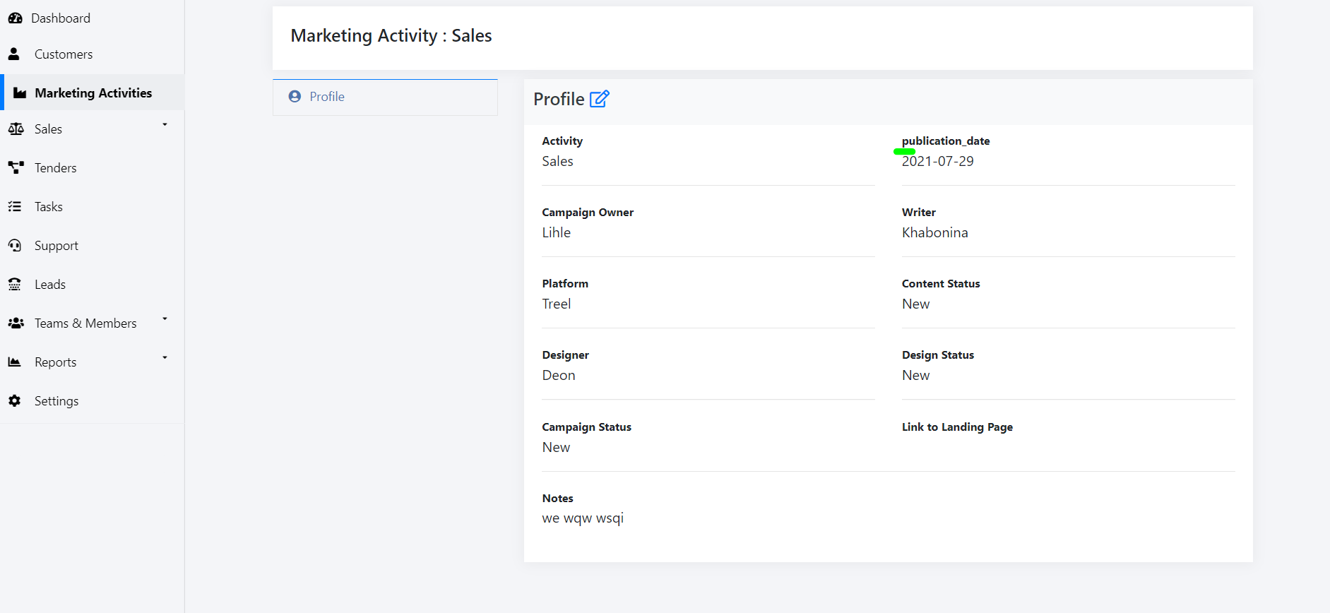

- A user is able to save the marketing activities without selecting a publication date but “publication date” is marked with an asterisk which means it is mandatory. It should also display this 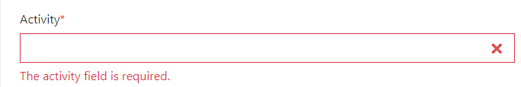

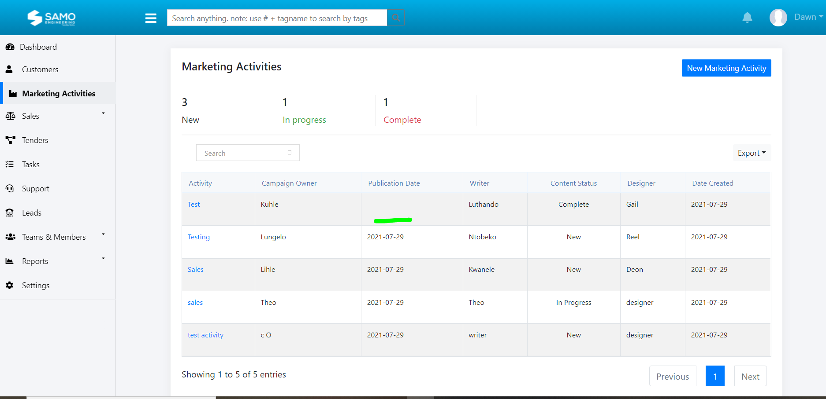
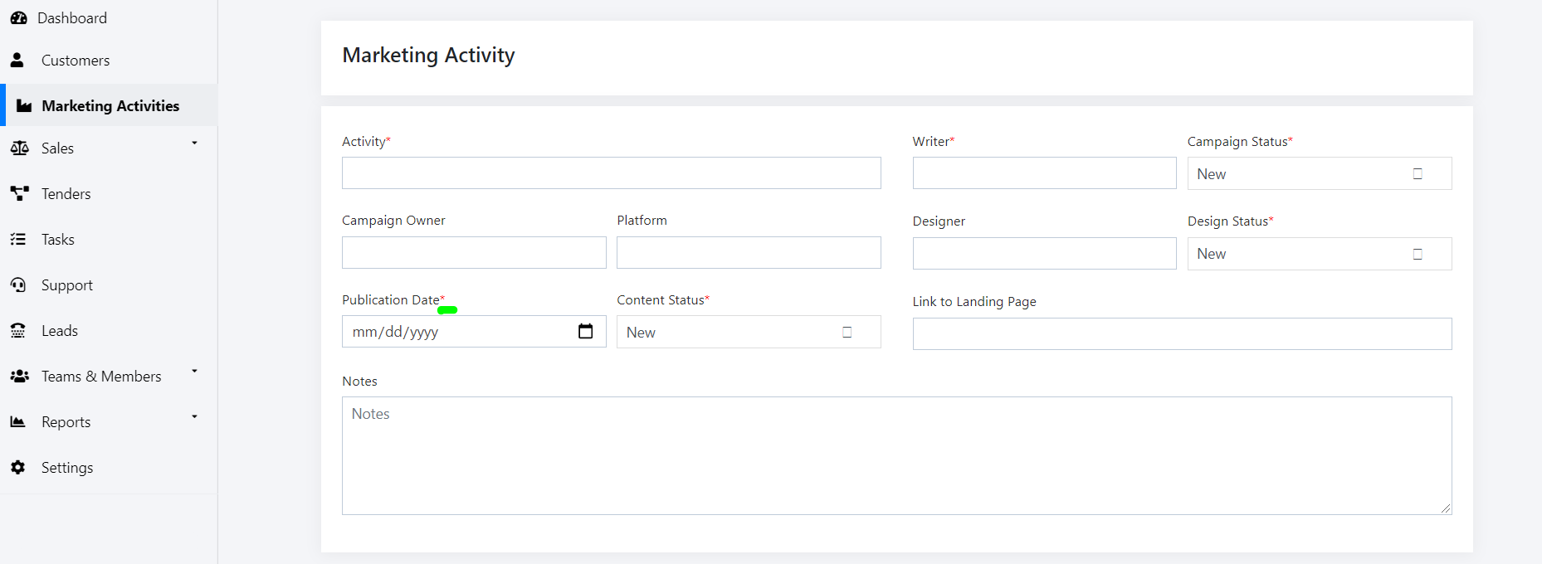

- The tick box is not working its not a tick box its an icon that is not showing
